According to Intelli, the Italy diagnostic centers market was valued at USD 1,441.83 million in 2024 and is projected to reach USD 2113.90 million by 2032, growing at a CAGR of 5.80% over the forecast period of 2024-2032.

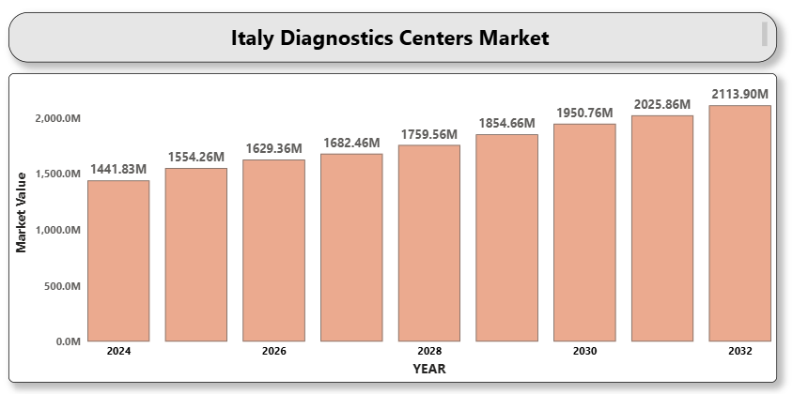

Italy’s healthcare system, which combines public and private services, supports a growing network of diagnostic centers across urban and semi-urban areas. The market growth is propelled by increased demand for advanced diagnostic imaging and laboratory tests, raising incidence of chronic diseases, and the expansion of digital health infrastructure.

**Italy diagnostic centers Market Definition**

Diagnostic centers are specialized medical facilities equipped to conduct tests and procedures to identify, monitor, and evaluate diseases, conditions, or injuries. Services provided include imaging diagnostics (like MRI, CT, X-ray, and ultrasound), pathology testing, genetic screening, and cardiac diagnostics. These centers play a pivotal role in the early detection and management of medical conditions, thus forming a critical component of the healthcare ecosystem.

In Italy, diagnostic centers operate as standalone units or within hospitals and clinics. The sector is experiencing modernization driven by increasing healthcare awareness, technological advancements, aging population, and government emphasis on early disease diagnosis and preventive care.

**Italy diagnostic centers Market Overview**

The public healthcare system under the Servizio Sanitario Nazionale (SSN) subsidizes diagnostic services, improving access and affordability. Additionally, private diagnostic service providers are investing in state-of-the-art imaging modalities, AI-driven analytics, and patient-centric digital platforms to cater to the tech-savvy population and reduce diagnosis turnaround times.

Screening programs for cancer, cardiovascular diseases, and metabolic disorders have gained momentum, increasing the need for reliable and scalable diagnostic infrastructure. Furthermore, post-COVID healthcare reforms and increased telehealth integration have further catalyzed investment in diagnostics.

The trend of outpatient diagnostics is also on the rise, as patients seek convenient, fast, and high-quality diagnostic services. Portable imaging equipment, point-of-care testing, and decentralized diagnostics are reshaping the operational models of Italian diagnostic centers.

**Italy diagnostic centers Market Segment Analysis**

**By Service Type**

* **Imaging Services:** Include X-rays, MRI, CT scans, ultrasound, and PET scans. These remain the most common diagnostic tools, with strong demand in oncology, cardiology, and orthopedics.
* **Pathology Services:** Comprise blood tests, urinalysis, histopathology, and molecular diagnostics. Increasing demand is driven by cancer detection and chronic disease monitoring.
* **Cardiology Diagnostics:** Encompass ECG, stress testing, and echocardiography. Rising cardiovascular diseases among the elderly population is a key growth factor.
* **Genetic Testing:** Gaining ground in Italy due to growing awareness of inherited disorders, cancer screening, and reproductive health.
* **Others:** Includes ophthalmic diagnostics, neurology-related tests, and specialty screenings.

**By End User**

* **Hospitals:** In-house diagnostic labs and imaging departments are critical in both public and private hospitals.
* **A close-up of hands holding a tablet and a pen

  Description automatically generatedStandalone Diagnostic Centers:** Offer flexible scheduling, cost-effective packages, and quicker reporting. They are gaining popularity in urban regions.
* **Clinics and Physician Offices:** Small-scale diagnostic setups associated with individual practices for quicker basic testing.
* **Home Healthcare Providers:** Enabled by telehealth and mobile diagnostic kits, this segment is expanding for elderly and chronically ill patients.

**Italy diagnostic centers market Competitive Landscape**

The Italy diagnostic centers market features both multinational diagnostic service chains and local healthcare providers. Strategic collaborations, diagnostic-as-a-service models, and digital innovations are helping providers offer comprehensive, accurate, and fast diagnostic solutions.

Firms are focusing on AI-enabled imaging systems, integrated health record platforms, and patient-friendly booking and reporting systems. Accreditation, cost control, and service customization are crucial to stay competitive.

**Key Profiles of Italy diagnostic centers**

* Synlab Italia
* Alliance Medical Group
* Cerba HealthCare Italia
* Lifebrain Group
* GVM Care & Research
* Istituto Clinico Humanitas
* Gruppo CDC
* Bracco Imaging S.p.A.
* Affidea Italia
* Euromedica Italia
* A close-up of hands holding a tablet and a pen

  Description automatically generatedMedica Group
* Centro Diagnostico Italiano (CDI)
* Lifenet Healthcare
* Blue Assistance

**Key Developments**

* **On September 9, 2024**, Roche introduced its **Digital Pathology Open Environment**, integrating advanced AI-based pathology solutions aimed at enhancing diagnostic precision and supporting clinicians in delivering improved and personalized patient care.
* **On March 12, 2025**, **Eurobio Scientific** announced the expansion of its presence in Italy, marking a strategic move to strengthen its position in the European diagnostics market.
* **In 2024**, **IrisCheck**, based in Udine, Italy, was founded as an innovative service offering AI-driven iridology analysis. By combining advanced technology with traditional practices, it provides quick and accurate insights into health, personality traits, and genetic predispositions—promoting self-awareness and preventive healthcare.

**Market Attractiveness**

Italy's universal healthcare coverage, strong focus on preventive care, and integration of smart diagnostic technologies make it an attractive market for diagnostic centers. Increasing consumer health awareness and digital transformation are further driving investment and innovation.

**Porter’s Five Forces Analysis**

* **Threat of New Entrants:** Moderate – High entry costs and need for regulatory approval restrict new players.
* **A close-up of hands holding a tablet and a pen

  Description automatically generatedBargaining Power of Suppliers:** Low to Moderate – Large centers can negotiate better deals with equipment and reagent providers.
* **Bargaining Power of Buyers:** High – Patients and insurers demand fast, affordable, and accurate diagnostic services.
* **Threat of Substitutes:** Low – Clinical diagnostics are essential and have few practical alternatives.
* **Competitive Rivalry:** High – Many regional players and global chains compete on technology, pricing, and turnaround time.

**Table of Contents**

1. **Introduction of Italy Diagnostic Centers Market**
   * 1.1 Overview of the Market
   * 1.2 Scope of Report
   * 1.3 Assumptions
2. **Executive Summary**
3. **Research Methodology**
   * 3.1 Data Mining
   * 3.2 Validation
   * 3.3 Primary Interviews
   * 3.4 List of Data Sources
4. **Italy Diagnostic Centers Market Outlook**
   * 4.1 Market Definition
   * 4.2 Market Overview
   * 4.3 Porter’s Five Forces Model
   * 4.4 Value Chain Analysis
5. **Market, by Service Type**
   * 5.1 Imaging Services
   * 5.2 Pathology Services
   * 5.3 Cardiology Diagnostics
   * 5.4 Genetic Testing
   * 5.5 Others
6. **Market, by End User**
   * 6.1 Hospitals
   * 6.2 Standalone Diagnostic Centers
   * 6.3 Clinics and Physician Offices
   * 6.4 Home Healthcare Providers
7. **Competitive Landscape**
   * 7.1 Overview
   * 7.2 Company Market Ranking
   * A close-up of hands holding a tablet and a pen

     Description automatically generated7.3 Key Development Strategies
8. **Company Profiles**

**8.1 Synlab Italia**  
8.1.1 Overview  
8.1.2 Financial Performance  
8.1.3 Product Outlook  
8.1.4 Key Developments

**8.2 Alliance Medical Group**  
8.2.1 Overview  
8.2.2 Financial Performance  
8.2.3 Product Outlook  
8.2.4 Key Developments

**8.3 Cerba HealthCare Italia**  
8.3.1 Overview  
8.3.2 Financial Performance  
8.3.3 Product Outlook  
8.3.4 Key Developments

**8.4 Lifebrain Group**  
8.4.1 Overview  
8.4.2 Financial Performance  
8.4.3 Product Outlook  
8.4.4 Key Developments

**8.5 GVM Care & Research**  
8.5.1 Overview  
8.5.2 Financial Performance  
8.5.3 Product Outlook  
8.5.4 Key Developments

**8.6 Istituto Clinico Humanitas**  
8.6.1 Overview  
8.6.2 Financial Performance  
8.6.3 Product Outlook  
8.6.4 Key Developments

**8.7 Gruppo CDC**  
8.7.1 Overview  
8.7.2 Financial Performance  
8.7.3 Product Outlook  
8.7.4 Key Developments

**8.8 Bracco Imaging S.p.A.**  
8.8.1 Overview  
8.8.2 Financial Performance  
8.8.3 Product Outlook  
8.8.4 Key Developments

**8.9 Affidea Italia**  
8.9.1 Overview  
8.9.2 Financial Performance  
8.9.3 Product Outlook  
8.9.4 Key Developments

**8.10 Euromedica Italia**  
8.10.1 Overview  
8.10.2 Financial Performance  
8.10.3 Product Outlook  
8.10.4 Key Developments

**8.11 Medica Group**  
8.11.1 Overview  
8.11.2 Financial Performance  
8.11.3 Product Outlook  
8.11.4 Key Developments

**8.12 Centro Diagnostico Italiano (CDI)**  
8.12.1 Overview  
8.12.2 Financial Performance  
8.12.3 Product Outlook  
8.12.4 Key Developments

**8.13 Lifenet Healthcare**  
8.13.1 Overview  
8.13.2 Financial Performance  
8.13.3 Product Outlook  
8.13.4 Key Developments

**8.14 Blue Assistance**  
8.14.1 Overview  
8.14.2 Financial Performance  
8.14.3 Product Outlook  
8.14.4 Key Developments

1. **Key Developments**
   * 9.1 Product Launches/Developments
   * 9.2 Mergers and Acquisitions
   * 9.3 Business Expansions
2. **Appendix**
   * 10.1 Related Research